Need to have these VM args and set the working dir in order for the dll’s to be found:
First, run the installer from the installer folder. TODO – deal with key
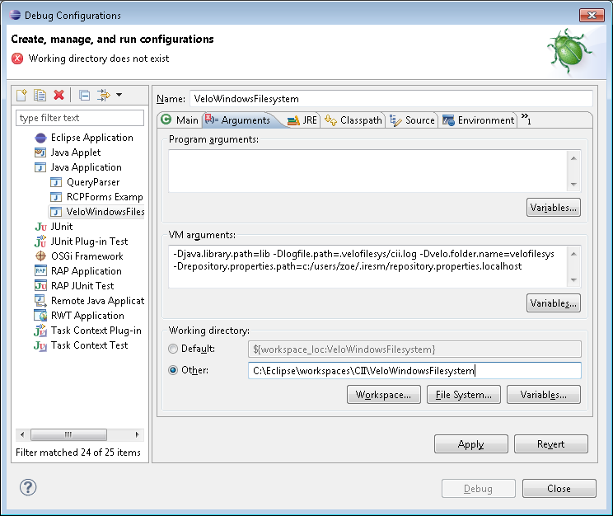
VM args:
-Djava.library.path=lib -Dlogfile.path=.velofilesys/cii.log -Dvelo.folder.name=velofilesys -Drepository.properties.path=c:/users/zoe/.iresm/repository.properties.localhost
Working dir:
The path to the checked out VeloWindowsFilesystem project

